Supplementary Materials
Table S1. Descriptive of the DSM-5 CD and ODD symptoms used for the network models.
Disorder: Symptom # | Dimensions | P-CAPP | Brief Description | Mean | SD
CD1 | Aggression | 4 | bully | 0.89 | 1.25
CD2 | Aggression | 90 | fight | 0.51 | 0.97
CD3 | Aggression | 89 | weapon | 0.23 | 0.77
CD4 | Aggression | 95 | cruel people | 0.58 | 1.03
CD5 | Aggression | 31 | cruel animals | 0.12 | 0.50
CD6 | Aggression | 77 | Stolen: confronting | 0.26 | 0.76
CD9 | Destruction property | 16 | destroy | 0.65 | 1.07
CD11 | Deceitfulness/theft | 53 | lies | 1.82 | 1.57
CD12 | Deceitfulness/theft | 73 | Stolen: not confronting | 0.46 | 1.02
CD13 | Serious rules violations | 44 | out at night | 0.21 | 0.73
CD14 | Serious rules violations | 17 | run away | 0.57 | 1.06
CD15 | Serious rules violations | 63 | truant | 0.65 | 1.28
ODD1 | Anger/irritable mood | 113 | temper | 2.26 | 1.53
ODD2 | Anger/irritable mood | 92 | touchy | 2.48 | 1.51
ODD3 | Anger/irritable mood | 20 | angry | 2.09 | 1.54
ODD4 | Argumentative/defiant | 102 | argues | 2.31 | 1.62
ODD5 | Argumentative/defiant | 26 | defies | 2.21 | 1.53
ODD6 | Argumentative/defiant | 80 | annoys | 1.62 | 1.56
ODD7 | Argumentative/defiant | 110 | blames | 2.07 | 1.65
ODD8 | Vindictiveness | 14 | spiteful | 2.01 | 1.62
Note: P-CAPP = Children and adolescent PsychProfiler

Table S2. Intercorrelations among the Conduct Disorder (CD) Oppositional Defiant Disorder (ODD) symptoms.
- | CD1 | CD2 | CD3 | CD4 | CD5 | CD6 | CD9 | CD11 | CD12 | CD13 | CD14 | CD15 | ODD1 | ODD2 | ODD3 | ODD4 | ODD5 | ODD6 | ODD7 | ODD8
CD1 | 1.00 | 0.70 | 0.53 | 0.67 | 0.26 | 0.38 | 0.61 | 0.45 | 0.45 | 0.26 | 0.46 | 0.26 | 0.59 | 0.50 | 0.59 | 0.53 | 0.52 | 0.54 | 0.52 | 0.65
CD2 | - | 1.00 | 0.63 | 0.76 | 0.29 | 0.39 | 0.59 | 0.37 | 0.42 | 0.22 | 0.44 | 0.25 | 0.50 | 0.42 | 0.47 | 0.45 | 0.42 | 0.53 | 0.44 | 0.51
CD3 | - | - | 1.00 | 0.60 | 0.27 | 0.39 | 0.52 | 0.31 | 0.47 | 0.22 | 0.37 | 0.24 | 0.34 | 0.30 | 0.34 | 0.31 | 0.31 | 0.38 | 0.32 | 0.35
CD4 | - | - | - | 1.00 | 0.32 | 0.43 | 0.63 | 0.41 | 0.49 | 0.18 | 0.43 | 0.21 | 0.54 | 0.43 | 0.51 | 0.45 | 0.43 | 0.57 | 0.48 | 0.56
CD5 | - | - | - | - | 1.00 | 0.35 | 0.32 | 0.22 | 0.32 | 0.11 | 0.16 | 0.16 | 0.27 | 0.21 | 0.25 | 0.24 | 0.24 | 0.32 | 0.24 | 0.25
CD6 | - | - | - | - | - | 1.00 | 0.46 | 0.36 | 0.52 | 0.26 | 0.34 | 0.27 | 0.36 | 0.26 | 0.34 | 0.35 | 0.39 | 0.37 | 0.36 | 0.36
CD9 | - | - | - | - | - | - | 1.00 | 0.46 | 0.56 | 0.19 | 0.52 | 0.32 | 0.54 | 0.41 | 0.52 | 0.45 | 0.49 | 0.56 | 0.48 | 0.55
CD11 | - | - | - | - | - | - | - | 1.00 | 0.55 | 0.25 | 0.39 | 0.26 | 0.49 | 0.35 | 0.46 | 0.53 | 0.59 | 0.52 | 0.64 | 0.47
CD12 | - | - | - | - | - | - | - | - | 1.00 | 0.22 | 0.47 | 0.31 | 0.38 | 0.32 | 0.40 | 0.38 | 0.42 | 0.45 | 0.44 | 0.40
CD13 | - | - | - | - | - | - | - | - | - | 1.00 | 0.56 | 0.33 | 0.23 | 0.15 | 0.19 | 0.17 | 0.21 | 0.13 | 0.16 | 0.17
CD14 | - | - | - | - | - | - | - | - | - | - | 1.00 | 0.39 | 0.42 | 0.33 | 0.41 | 0.38 | 0.42 | 0.36 | 0.39 | 0.40
CD15 | - | - | - | - | - | - | - | - | - | - | - | 1.00 | 0.29 | 0.27 | 0.27 | 0.27 | 0.31 | 0.21 | 0.23 | 0.24
ODD1 | - | - | - | - | - | - | - | - | - | - | - | - | 1.00 | 0.65 | 0.72 | 0.68 | 0.57 | 0.56 | 0.65 | 0.77
ODD2 | - | - | - | - | - | - | - | - | - | - | - | - | - | 1.00 | 0.69 | 0.56 | 0.44 | 0.49 | 0.53 | 0.62
ODD3 | - | - | - | - | - | - | - | - | - | - | - | - | - | - | 1.00 | 0.62 | 0.55 | 0.52 | 0.62 | 0.76
ODD4 | - | - | - | - | - | - | - | - | - | - | - | - | - | - | - | 1.00 | 0.72 | 0.59 | 0.68 | 0.64
ODD5 | - | - | - | - | - | - | - | - | - | - | - | - | - | - | - | - | 1.00 | 0.58 | 0.64 | 0.55
ODD6 | - | - | - | - | - | - | - | - | - | - | - | - | - | - | - | - | - | 1.00 | 0.62 | 0.55
ODD7 | - | - | - | - | - | - | - | - | - | - | - | - | - | - | - | - | - | - | 1.00 | 0.63
ODD8 | - | - | - | - | - | - | - | - | - | - | - | - | - | - | - | - | - | - | - | 1.00
Note. All correlation are significant at the 0.01 level (2-tailed).
Table S3. Edge weights in the network analysis.
Nodes | CD1 | CD2 | CD3 | CD4 | CD5 | CD6 | CD9 | CD11 | CD12 | CD13 | CD14 | CD15 | ODD1 | ODD2 | ODD3 | ODD4 | ODD5 | ODD6 | ODD7 | ODD8
CD1 | 0.00 | 0.23 | 0.00 | 0.09 | −0.08 | 0.00 | 0.10 | 0.03 | 0.00 | 0.00 | 0.04 | −0.02 | 0.00 | 0.00 | 0.07 | 0.00 | 0.04 | 0.00 | 0.00 | 0.24
CD2 | - | 0.00 | 0.27 | 0.40 | 0.00 | 0.00 | 0.02 | 0.00 | 0.00 | 0.00 | 0.00 | 0.00 | 0.06 | 0.01 | 0.00 | 0.01 | 0.00 | 0.10 | 0.00 | 0.00
CD3 | - | - | 0.00 | 0.23 | 0.12 | 0.10 | 0.10 | −0.02 | 0.08 | 0.08 | 0.00 | 0.06 | 0.00 | 0.03 | 0.00 | 0.00 | 0.00 | 0.00 | 0.00 | −0.02
CD4 | - | - | - | 0.00 | 0.11 | 0.00 | 0.13 | 0.00 | 0.01 | −0.01 | 0.00 | 0.00 | 0.04 | 0.03 | 0.00 | 0.00 | 0.00 | 0.11 | 0.00 | 0.05
CD5 | - | - | - | - | 0.00 | 0.21 | 0.06 | 0.00 | 0.04 | 0.13 | −0.08 | 0.00 | 0.07 | 0.00 | 0.02 | 0.02 | 0.00 | 0.18 | −0.04 | −0.02
CD6 | - | - | - | - | - | 0.00 | 0.00 | 0.12 | 0.24 | 0.15 | 0.00 | 0.09 | 0.00 | 0.00 | 0.00 | 0.00 | 0.08 | 0.09 | 0.00 | 0.02
CD9 | - | - | - | - | - | - | 0.00 | 0.00 | 0.13 | −0.18 | 0.30 | 0.00 | 0.00 | 0.00 | 0.00 | 0.00 | 0.06 | 0.06 | 0.00 | 0.13
CD11 | - | - | - | - | - | - | - | 0.00 | 0.33 | 0.03 | 0.00 | 0.00 | 0.00 | −0.07 | 0.00 | 0.00 | 0.14 | 0.02 | 0.24 | 0.00
CD12 | - | - | - | - | - | - | - | - | 0.00 | 0.05 | 0.05 | 0.12 | 0.00 | 0.00 | 0.00 | 0.00 | 0.00 | 0.06 | 0.01 | 0.00
CD13 | - | - | - | - | - | - | - | - | - | 0.00 | 0.56 | 0.18 | 0.08 | 0.00 | 0.00 | 0.00 | 0.00 | −0.16 | −0.01 | −0.07
CD14 | - | - | - | - | - | - | - | - | - | - | 0.00 | 0.03 | 0.00 | 0.00 | 0.07 | 0.00 | 0.08 | 0.00 | 0.00 | 0.00
CD15 | - | - | - | - | - | - | - | - | - | - | - | 0.00 | 0.00 | 0.08 | 0.00 | 0.00 | 0.00 | 0.00 | 0.00 | 0.00
ODD1 | - | - | - | - | - | - | - | - | - | - | - | - | 0.00 | 0.18 | 0.07 | 0.16 | 0.00 | 0.00 | 0.13 | 0.28
ODD2 | - | - | - | - | - | - | - | - | - | - | - | - | - | 0.00 | 0.33 | 0.09 | 0.00 | 0.05 | 0.04 | 0.00
ODD3 | - | - | - | - | - | - | - | - | - | - | - | - | - | - | 0.00 | 0.03 | 0.01 | 0.00 | 0.05 | 0.34
ODD4 | - | - | - | - | - | - | - | - | - | - | - | - | - | - | - | 0.00 | 0.37 | 0.06 | 0.22 | 0.05
ODD5 | - | - | - | - | - | - | - | - | - | - | - | - | - | - | - | - | 0.00 | 0.04 | 0.09 | 0.00
ODD6 | - | - | - | - | - | - | - | - | - | - | - | - | - | - | - | - | - | 0.00 | 0.20 | 0.00
ODD7 | - | - | - | - | - | - | - | - | - | - | - | - | - | - | - | - | - | - | 0.00 | 0.05
ODD8 | - | - | - | - | - | - | - | - | - | - | - | - | - | - | - | - | - | - | - | 0.00

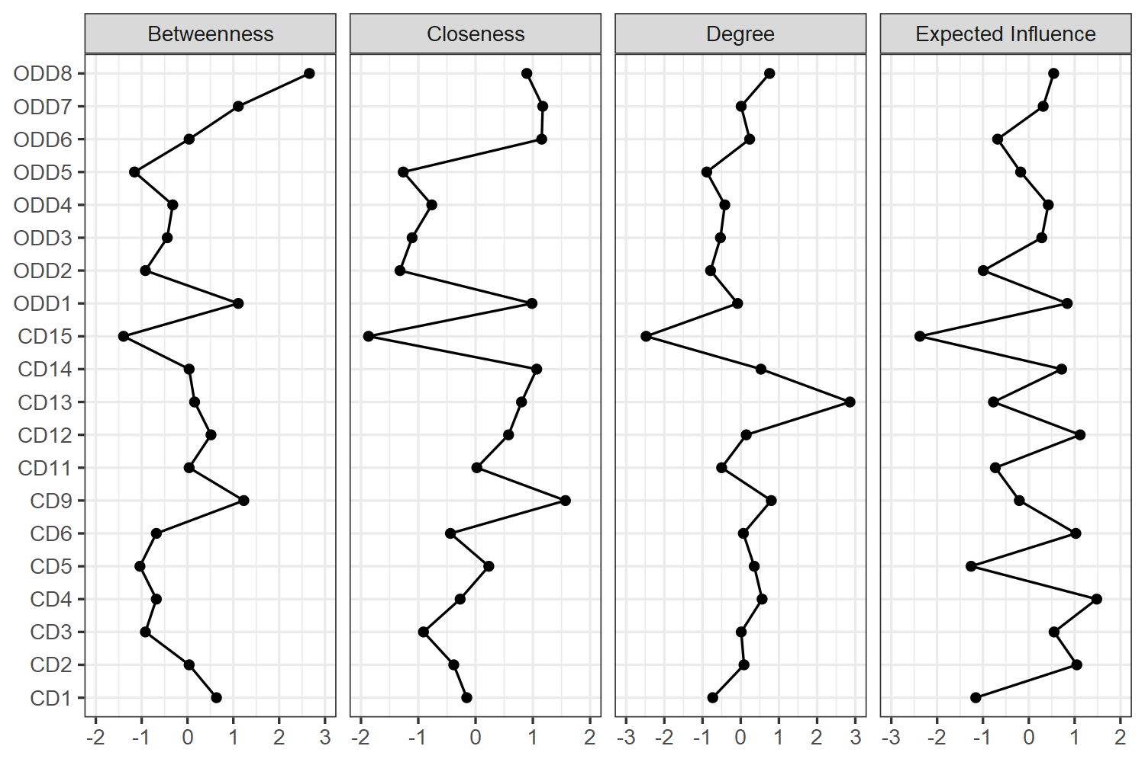
Figure S1. Centrality plots (betweenness, closeness, degree, and expected influence) in the network for both CD and ODD symptoms together. Note. Values shown on the x-axis are standardized z-scores.
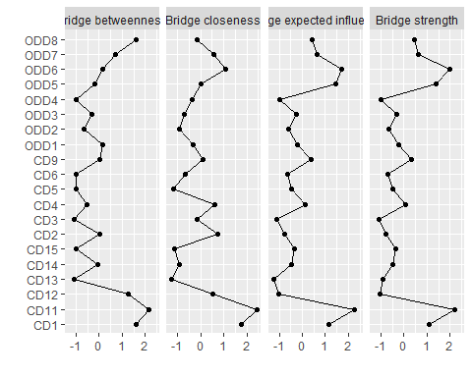
Figure S2. Bridge symptom indices for the ODD and CD symptoms. Note. The horizontal axis represents sums of weights and frequency of bridge symptoms across ODD and CD. The vertical axis represents each ODD and CD symptoms.
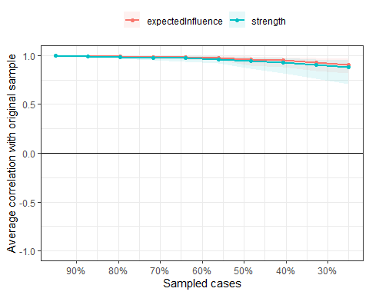
Figure S3. Stability of centrality indices by case dropping subset bootstrap. Note. The graph shows the average correlation between bootstrap centrality indices of networks sampled with node-dropping. A strong correlation after dropping a high percentage of participants indicate that centrality measures in the original network can be considered robust. Red lines indicate the average correlation between the expected influence in the original sample and the expected influence in the sample.
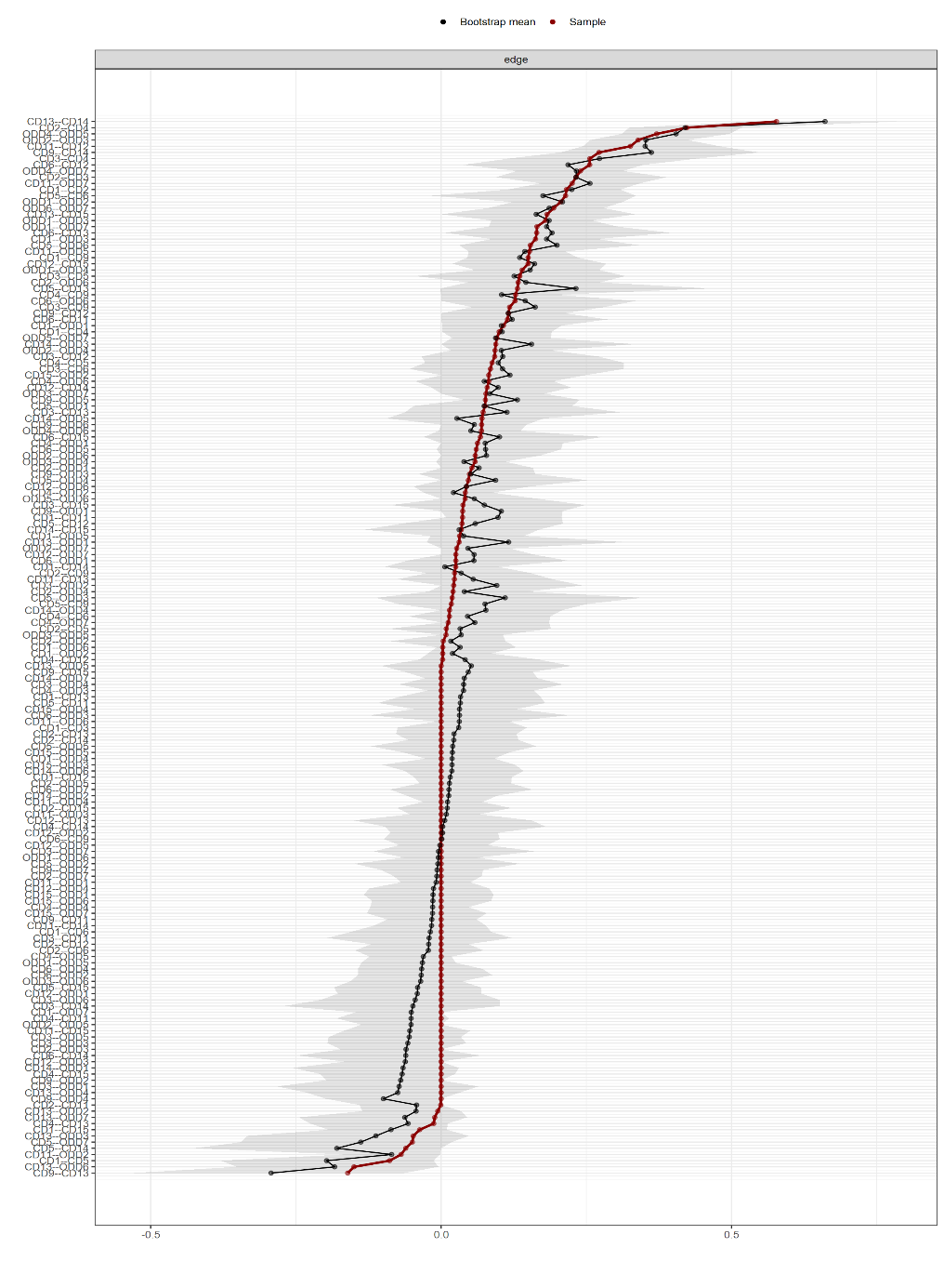
Figure S4. Edge stability estimate for the CD symptoms in network analysis of both CD and ODD symptoms together. Note. The x-axis represents the edges, while every line on the y-axis represents a specific edge. The red line shows the estimate of the edge weights, and the grey bars the 95% confidence intervals for the estimates.
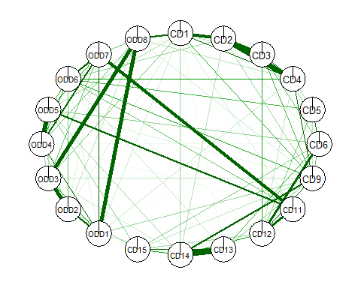
Figure S5. Community detection with node assignment according to the clique percolating algorithm.

